**Analysis of survey answers given by females**

**Statistics – Question 1** 2

*What do you consider to be commonsense knowledge when washing clothes?* 2

**Statistics – Question 2** 4

*What do you consider to be commonsense knowledge when doing dishes?* 4

**Statistics – Question 3** 6

*What do you consider to be commonsense knowledge when vacuuming?* 6

**Statistics – Question 4** 8

*What do you consider to be commonsense knowledge when cooking?* 8

**Statistics – Question 5** 10

*What do you consider to be commonsense knowledge when cleaning windows?* 10

**Average statistics** 12

*Average Gunning Fox Index* 12

# **Statistics – Question 1**

### *What do you consider to be commonsense knowledge when washing clothes?*

The cleaner the better.

Het scheiden van verschillende soorten kleding, waspoeder/waspods gebruiken, wasprogramma selecteren die past bij het wasgoed.

Dat je niet alles bij elkaar gooit maar het verdeeld.

-You need soap.

-Every piece of clothing has a label that tells you how to wash it.

Know the different programmes. know how to sort clothes. know the detergents.

Know how the washing machine works.

Know which clothes belong together in the washing machine.

Don't mix colors. check the labels for instructions. watch out for soft clothes. put hoodies/jeans reversed and zipped up, check pockets before washing.

Temperature, color, washing liquid.

welke kleuren je bij elkaar kan wassen en op welke stand en temperatuur je dit moet wassen.

That you need to separate white from colour clothing.

Using the washingmachine.

Sorting clothes.

Color by color.

Het scheiden van kleuren.

Kleur apart van wit.

how to turn the machine on and off. what program you should use. that black clothes should go together etc.

Just pressing the button and wait till it's done.

Use the right temperature with the material or clothing type that you are going to wash.

What to wash seperately.

All the clothes have to be and look clean and have to smell fresh after I washed them.

Wassen.

Never mix Colors and White.

Je moet weten hoe de hele procedure in elkaar zit.

Do not wash color clothes together with white (light color) clothes.

Do not use high temperature for dark color clothes.

Do not use bleach for clothes of any color other than white.

Use pre-wash cycle for heavily dirty clothes.

different fabrics require to be washed at different temperatures.

Separate colors, keep the temperature low unless there are stains, high temperatures cause colors to fade. the main detergent goes in the largest receptacle.

- when clothes come in contact with water, they become wet.

used on clothes that are dirty.

typically automated using washing machine, requires electricity .

clothing gets wet.

uses some kind of soap.

machine uses centrifuge to get most of the water out.

takes roughly an hour when using machine.

clothes come out clean, usually.

within certain bounds, higher water temperature washes better.

when water temperature is too high, clothes can shrink permanently .

some dyes (primarily red) can transfer to other clothing items.

clothes can be hung to dry or put in a dryer.

Separate textile types before washing, distinguish in general between high and low temperature washing.

Separate colours, put them in water first and add soap, rinse.

Detergent is needed.

Detergent can be in liquid or in powered form.

You can select a temperature and sometimes a program on the washing machine.

You need to check the temperature recommendation on the cloths' labels in order to select right temperature on the machine.

Clothes are washed when dirty. Usually with water. Lights apart from Darks. They need to be hanged as soon as possible, otherwise you need to iron.

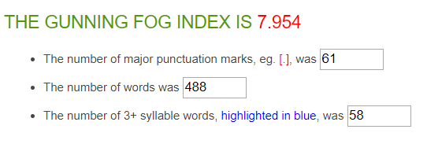

|  |  |
| --- | --- |
| Average Word Length (char) | 5.1 |
| Average Sentence Length (word) | 7.5 |
| Monosyllabic Words (1 syllable) | 264 |
| Polysyllabic Words (≥3 syllables) | 71 |

**65 sentences in total**

**32 answers in total**

**On average: 2.0 sentences per answer, with a sentence length of 7.5 words per sentence.**

# **Statistics – Question 2**

### *What do you consider to be commonsense knowledge when doing dishes?*

To use cif while doing the dishes and close the tab.

Spoelen, afwasmiddel zetten op schuurspons.

Zachte kant schuurspons gebruiken bij objecten die gevoelig zijn voor krassen. indien je geen krassen wilt, drogen met handdoek.

Dat je eerst de spullen afspoelt.

-You need soap, water and a sponge or a dishwasher.

-You clean the dishes using the sponge.

-You might get wet when you use too much water.

Using the soap and know how to wash.

Know how the dishwasher works.

being careful with handling them, not scrubbing pans with special coatings, use soap sparingly.

1. Dishes should be wiped dry after washing them.

2. Do not use a hard scrubbing sponge to wash certain dishes.

In which order you need to wash it.

Use soap.

Use warm water.

Doing the bigger dishes first, using a clean sponge.

Use dish soap. Rinse the dishes.

Turn off the water when washing the dishes with soap.

Get the dishes wet.

Be careful cause dishes can break fairly easily, don’t burn your hands, use soap.

Also press the button on ‘cleaning’.

Using slightly warm water.

Wash and dry.

Soap.

How the machine works.

Use dishwasher.

Hoeveelheid wasmiddel bepalen.

Water is required to clean dished.

You need a sponge, water and soap.

Removing dirt means cleaning.

you need soap and water.

- you need to close the dishwasher in order to run it.

process to turn dirty dishes into clean dishes.

typically automated using dishwasher, requires electricity.

uses some kind of soap.

dishes get wet.

takes a couple of hours in the machine.

takes roughly an hour when done manually.

dishes come out clean, usually.

within certain bounds, higher water temperature washes better.

when water temperature is too high, some dishes are damaged.

plastic containers may deform when put into the machine.

The main methods for doing dishes are either by washing in a sink, or using a dish washer. Both methods involve water, usually warm.

You need a container of warm or hot water (usually a sink). The dishes should be immersed into the water. The surface of the dishes should be in contact with some dishwashing liquid. Usually, this is done by pouring the liquid into the water. You can use either a brush or a sponge to clean the dirt of the dishes.

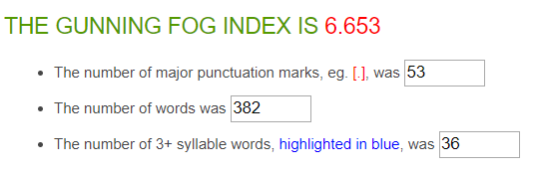

|  |  |
| --- | --- |
| Average Word Length (char) | 4.8 |
| Average Sentence Length (word) | 7.1 |
| Monosyllabic Words (1 syllable) | 215 |
| Polysyllabic Words (≥3 syllables) | 39 |

**54 sentences in total**

**30 answers in total**

**On average: 1.8 sentences per answer, with a sentence length of 7.1 words per sentence.**

# **Statistics – Question 3**

### *What do you consider to be commonsense knowledge when vacuuming?*

To turn on the vacuumer and use electricity.

Kleine voorwerpen die weggezogen kunnen worden eerst verwijderen van de vloer.

Dat je alles stofzuigt ook in de hoeken.

-The vacuum cleaner has to move around in order for you to clean your space.

-The vacuum cleaner sucks all the air in.

-Some small items can be sucked in so you have to be careful with that.

Do the whole house.

use the two modes when switching from hard to soft floors, extend the pole to reach difficult spots, always fully extend the power cord. if you have multiple power levels put in on full power for hard floors, don't vacuum wet stuff unless your vacuum can handle it.

Every corner.

hoe je de vloer schoon maakt.

Know how to use it.

Starting at the corners.

That you should shift to the front and the back, everyone vacuums in the same way/pattern I think.

Take the corners with you.

dust goes in the vaccuum.

See if there is a vacuum bag inside. Put the plug in. Vacuum the floor.

Don't forget the corners while vacuuming.

To have a bag inside.

No soap.

There have to be no dust, sand or waste on the floor, after I cleaned it.

Keep the machine connected to the hose.

Vacuuming allows to remove dirt from the floor.

Empty the dust container for better performance.

Clean the brush for better performance.

Change the socket when moving between rooms. Change the bag when the vacuum cleaner stops working. Remove the vacuum head to clean corners.

- The vacuum cleaner needs to be plugged to a power socket.

- The vacuum cleaner needs to be on.

- You need to have some dirt on the floor to vacuum.

Remove small objects from the floor.

A vacuum cleaner needs to be turned on for it to work. You push and pull the long end of the machine over the floor. It sucks up dirt. The dirt ends up in a sac in the machine, which needs to be replaced once in a while when it is full. The machine needs to be turned off when you are done. You should avoid sucking up small items on the floor that are not dirt.

the vacuum sucks op the dust, it makes noise, it does not work well on liquids, the vacuum is heavy, it does not fit under all furniture, the cable limits its operational radius, the hose can act in surprising ways, the cable rolls up automatically.

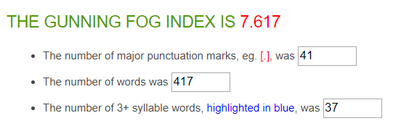

|  |  |
| --- | --- |
| Average Word Length (char) | 4.3 |
| Average Sentence Length (word) | 9.7 |
| Monosyllabic Words (1 syllable) | 274 |
| Polysyllabic Words (≥3 syllables) | 30 |

**43 sentences in total**

**26 answers in total**

**On average: 1.7 sentences per answer, with a sentence length of 9.7 words per sentence.**

# **Statistics – Question 4**

### *What do you consider to be commonsense knowledge when cooking?*

Turn on the gas and use oil.

Handen wassen van te voren, schone koomomgeving hebben, veilige kookomgeving hebben.

Dat je steeds test en daarop smaak aanpast.

-Fire is hot so be careful.

-You have to pay attention because you don't want a mess or burn your food.

Know when and how much oil to use, how much fire you should use.

The time, Herbs, Oil, Pepper and salt.

don't leave spoons etc. in the pans. use the right amount of heat, don't leave something one the fire when you're not in the same room, use a burner not larger than the pan size.

Basic cooking skills.

verschillende gerechten kunnen maken.

When something is done you can taste it and you know when it is ready.

Clean and tidy.

Food.

Don’t let the meat be raw.

Washing ingredients before cooking.

Eerst voorbereiden.

That you should always use oil or butter in a baking pan. That you should put on the extractor hood.

Know when the meat or chicken is ready and take your time and enjoy cooking.

Pick the right ingredients.

Combinations of flavors.

The food have to be cooked (with fresh ingredients? and it has to taste good.

How to use the basics. Cook eggs. Was je kip before bakken. Dropped food goes into the bin

First, to prevent yourself from getting hurt and after that knowing how to make your food consumable.

How to cook in general?

tools, pots and pans should be cleaned before cooking.

use one's nose to check the ingredients.

process to provide enjoyable food for humans:

humans require food to produce energy/not die.

involves combining edible items.

"cooking" implies that heat was used on at least one of the ingredients.

some ingredients can only be eaten when cooked.

the following can change the resulting dish:

- ingredients used

- amount of each ingredient used

- the shape and size of the ingredients

- order of adding

- combination of steps in the process

- duration of each step in the process

usually requires:

- pots/pans

- stove/oven

- salt and oil

- meat

- vegetables

Cooking is the process of heating food to improve its edibility and taste. It often involves pans.

Water in a pan will come to a boil when pan is put on a stove and the stove is turned on. The higher the heat of the stove, the faster the water will come to a boil. If you add food to the water in the pan, the food will soften after some time. Pasta needs to be in boiling water for a predetermined amount of time for it to be edible. The amount of time needed for a particular type of pasta is often listed on the packaging.

Cooking is a way to make consumables easier to eat and perhaps more tasteful.

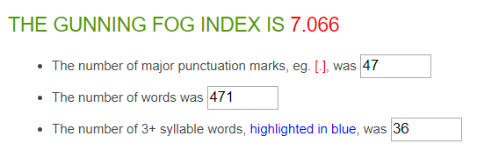

|  |  |
| --- | --- |
| Average Word Length (char) | 4.5 |
| Average Sentence Length (word) | 7.3 |
| Monosyllabic Words (1 syllable) | 283 |
| Polysyllabic Words (≥3 syllables) | 51 |

**63 sentences in total**

**26 answers in total**

**On average: 2.4 sentences per answer, with a sentence length of 7.3 words per sentence.**

# **Statistics – Question 5**

### *What do you consider to be commonsense knowledge when cleaning windows?*

Use papertowel.

Water met zeep mengen om een zeepsop te maken, veilige omgeving met ladder.

Dat je daarna met zo’n zeem het vocht eraf haalt.

-You can use a cloth to clean the windows

-You can use water with soap

-You can use Glassex

Use the right soap and wind cleaner and also clean window frames.

How to dry and also do doors.

start from top to bottom, don't clean them in direct sunlight, watch out for scratches.

Ramen droogmaken na schoonmaken / hoe je een raam schoon maakt.

The Order.

I dont know.

Wash first and dry after.

Use water and soap.

Close them.

use soap and water, wipe the window dry.

Use water with soap to wet the window.

Making smooth motions to avoid leaving lines.

Transparant.

The windows must be clean so that I can see through them, without seeing any stains.

Don’t use steel wool, windows can get dirty.

you need wiper and cleaning products.

Start from soaking wet windows.

Concerns for safety.

Drying with paper makes the glass free from stains.

Put soapy water on the windows, scrub and then dry the windows.

- Windows are, most of the time, fragile.

Remove dust before cleaning, use newspaper foils.

You need water and a detergent. You apply the water and the detergent to the window using a tool, usually a sponge or a cloth. Then, you dry the window by 'scraping' off the water with a wiper.

water runs down to the bottom.

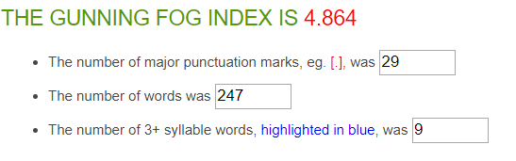

|  |  |
| --- | --- |
| Average Word Length (char) | 4.5 |
| Average Sentence Length (word) | 7.4 |
| Monosyllabic Words (1 syllable) | 153 |
| Polysyllabic Words (≥3 syllables) | 14 |

**33 sentences in total**

**26 answers in total**

**On average: 1.3 sentences per answer, with a sentence length of 7.4 words per sentence.**

# **Average statistics**

### *Average Gunning Fox Index*

(Composed by taking the average of all answers given by females)

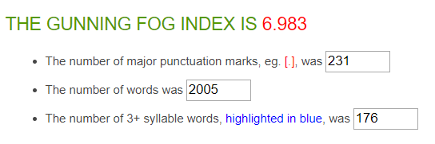

|  |  |
| --- | --- |
| Average Word Length (char) | 4.7 |
| Average Sentence Length (word) | 7.7 |
| Monosyllabic Words (1 syllable) | 1189 |
| Polysyllabic Words (≥3 syllables) | 205 |

**258 sentences in total**

**140 answers in total**

**On average: 1.8 sentences per answer, with a sentence length of 7.7 words per sentence.**